Document Number | ACNP2
Document Title | Pre-Employment Medical – Alliance Clinic
Department Ownership | Health and Wellness
Document Type | Procedure
Department Owner | Jason Ryan
Document Author | Derrick Chan
Last Edited By | Derrick Chan | Lasted Edited On | 08/05/2015

Purpose

The purpose of this document is to describe the methods that must be used when completing REDIMED Pre-Employment Medicals at our Alliance Clinics. This document is used to ensure the quality and results are reliable and of REDIMED standard.

A Full REDIMED Pre-Employment Medical consists of a Medical Assessment, Spirometry, Audiometric Assessment, Drug and Alcohol Test and Functional Capacity Assessment. Depending on company requirements, components may be added or removed.

REDIMED’s Functional Capacity Assessment (FCA) aims to identify any pre-existing injuries or conditions that may affect a candidate’s ability to perform the physical demands of their proposed job role. The FCA also assesses a candidate’s risk of injury or chronic disease based on their general physical capacity. The FCA is made up of 3 sections – Range of motion, General physical capacity and Job-specific capacity.

Scope

This applies to all REDIMED Alliance Clinic staff who undertake Pre-Employment Medicals.

Reference Documents

National Safety and Quality Health Service NSQHS Standards
Codes of practice

Definitions

Procedure – A document that details the purpose and scope of an activity and specifies what is to be done and by whom, how, when and why an activity is to be carried out. A procedure is a component of a process.

Forms – Various forms are used besides the PIR to provide records of the System’s operation and to address any issues or non-conformance arising in the Quality Management System relating to the work instructions, procedures, user manuals, reference tools, learning guides and any other non-QA related issues.

Range of motion - Joint range of motion is assessed for all major movements of the body to detect any existing restrictions. Areas with a previous injury beyond a simple
strain or sprain or reported pain are measured with a bubble inclinometer or goniometer.

General Physical Capacity - General physical testing involves cardiovascular fitness, flexibility, core strength, and lower limb function muscular endurance testing to give an indication of a candidate’s general physical capacity. Upper-limb and lower- limb testing is also performed to screen for pre-existing injuries and to identify any dysfunction which needs to be investigated further. General capacity tests are standard for all FCAs.

Job-Specific Capacity - Job-specific testing incorporates job-specific tasks which are inherent physical requirements of the job. These tasks will vary depending on the job and includes tasks such as floor-waist lifting, waist-head lifting, carrying, push/pull and any other manual tasks required for the job. A candidate who cannot adequately perform these tasks is likely to be at high risk of injury.

Summary - The FCA is an integral part of the REDIMED pre-employment medical assessment process. The thorough nature of the testing allows the employer to be confident that the candidate is physically fit for the job, or not

Flowcharts (Other Images)

Procedures

Once a booking has been made at your clinic by REDiMED you will receive an email outline what assessments need to be completed and the relevant documents will be attached. When putting together a file ensure the documents as set out in the following order:

- Booking form
- Identification
- Medical History
- Medical Assessment(s)
- Drug and Alcohol Screening Form
- Audiometric Testing Sheets
- Functional Capacity Assessment
- Extra testing (if required)
- Spirometry print out
Note: The order of the file is the same regardless of the company or candidates proposed occupation.
- Booking Form
- Ensure each component on the booking form is in the file.

- Identification

- Patient’s current form of photographic identification must be photocopied and added to file.
- Photocopied identification must be checked by each individual taking the candidate through (i.e physio, exercise physiologist, doctor)

- Medical History

- Patient is to complete the Medical History Form prior to assessment taking place.

- Ensure consent declaration is signed and witnessed prior to commencement of the medical assessment. Witness can be the Exercise Physiologist or Receptionist.

- Ensure the bottom of every page of the medical history is initialed by the patient prior to completing the medical assessment.

Medical History Review

- Medical Histories MUST be reviewed and queries by the Exercise Physiologist/Nurse/Physiotherapist and GP.

- Every “yes” response MUST have an examiner comment in the space provided.

- Information required is as below:
  - Diagnosis of injury/Illness (i.e lower back muscle strain)
  - If no formal diagnosis is reported state this (no formal diagnosis provided)
  - Date of injury/illness
  - Treatment received (physio/surgery etc) and how currently managed (via exercise etc)
  - Current presentation (i.e no pain or restriction reported)

- Candidate should also be questioned verbally ‘Are there any other current or previous injuries, illnesses or workers compensation claims not included in this Medical History?’

- Medical Assessment

- Prior to beginning medical assessment ensure each page with the below box needs the candidates full name and date of birth written.

Weight

- Instruct candidate to remove shoes and items from pocket and step on to the scales.
- Weight should be recorded in kilograms (kg).
- Completed by an Exercise Physiologist or Nurse.

Height

- Instruct candidate to remove shoes and stand with heels, back and head up against the wall underneath the measuring tape.
- The tape should be rolled down until level with the wall and flat on the candidate’s head.
- Height recorded in centimeters (cm).
- Completed by an Exercise Physiologist or Nurse.

BMI

- BMI is the individual’s weight divided by their height in meters squared.
- BMI should be recorded to 1 decimal place.
- Records BMI in the box indicated and tick the classification they fall into.
- This number can classify the individual as underweight, normal, overweight or obese
- Completed by an Exercise Physiologist or Nurse

Waist Circumference

- Place tape measure around the smallest part of the candidate mid-section for females and in line with the navel for males.
- Record waist circumference in centimeters (cm).
- Completed by an Exercise Physiologist or Nurse.

Hip Circumference

- Place tape measure around the largest part of the candidate’s gluteal region.
- Record hip circumference in centimeters (cm).
- Completed by an Exercise Physiologist or Nurse.

Waist to Hip Ratio

- Divide the waist measurement by the hip measurement to derive the waist to hip ratio.
- Record to two decimal places.
- Record Waist to Hip Ratio in box provided and tick the classification they fall into.
- Completed by an Exercise Physiologist or Nurse

Blood Pressure Test

- Instruct candidate to relax left arm on the bench with palm facing upwards (supine).
- The appropriate cuff type should be considered. Short cuff for an individual with a smaller arm, long cuff for personnel with larger arms and the large maroon cuff for candidates with elevated Blood Pressure or larger arms.
- The cuff should be fastened around the left arm with the arrow in alignment with the artery.
- Pump up cuff and then slowly release the air until the Korotkoff sounds can be heard and then a blood pressure reading can be taken.
- If blood pressure is classified within the ‘normal’ ranges then the medical may proceed.

- If blood pressure is between 150-168 Systolic and 90-100 Diastolic please use the chain of events below

- If blood pressure falls into any of the following 170/102, >180/>110 or >160/<70 please use flow chart below.

- Completed by an Exercise Physiologist or Nurse.

Heart Rate Test

- With palm facing upwards (supine), two fingers should be placed on the distal radial side of the forearm.
- Pulse should be counted for fifteen seconds and then multiplied by four resting heart rate to derive the in beats per minute (bpm).
- Completed by an Exercise Physiologist or Nurse.

Heart Sounds

- If candidates heart sound deviate from the normal the abnormal box must be ticked and deviations explaining in comments section.
- If candidate is requires a doctor review place provide candidate with a referral letter outlining the deviations observed, and requesting current treatment.
- Complete by a General practitioner /

Peripheral and other vessels

- If candidates peripheral and other vessels deviate from the normal the abnormal box must be ticked and deviations explaining in comments section.
- If candidate is requires a doctor review place provide candidate with a referral letter outlining the deviations observed, and requesting current treatment.
- Complete by a General practitioner.

Distance Vision Test

- Instruct the candidate to stand facing the distance vision chart at a distance of 3 meters.
- Read the smallest print visible with one eye lightly covered. Repeat with the other eye covered.
- If the candidate wears glasses, instruct them to complete the above with glasses.
- If contacts are worn while completing this test, this should be noted in the medical.
- Abnormal vision should be flagged to a Doctor.
- If glasses are required and not brought to the medical, the individual will need to return to complete this section.
- Completed by an Exercise Physiologist or Nurse.

Near vision

- Instruct the candidate to hold the card 30 cm away from the face and read the smallest print he/she can see with one eye lightly covered. Repeat with the other eye covered.
- If the candidate wears glasses, instruct them to complete the above with glasses.
- If contacts are worn while completing this test, this should be noted in the medical. The candidate is not required to complete testing without use of contacts.
- Abnormal vision should be flagged to Doctor.
- If glasses are required and not brought to the medical, the individual will need to return to complete this section.
- Completed by an Exercise Physiologist or Nurse.

Colour Vision Test

- Candidates should be instructed to identify the number shown on each plate within three seconds.
- Refer to the Ishihara scoring guide for interpretation of results.
- Completed by an Exercise Physiologist or Nurse.

Peripheral Vision

- If candidates peripheral vision deviate from the normal the abnormal box must be ticked and deviations explaining in comments section.
- Complete by a General practitioner.

Urinalysis

- Instruct candidate to provide a urine sample in the sample cup provided with the bathroom door closed.
- Tester is then required to dip urinalysis testing stick into sample ensuring all testing areas are covered.
- Wait for approximately 1-2minutes and compare the colour on testing strip to colour chart comparison on tube. (Wait times may vary between brands).
- Tick the appropriate box in the table below to indicate the urinalysis results.
- If glucose is detected in the urinalysis a Blood Sugar Level pin prick test MUST be completed and doctor must review to determine if a doctor’s letter is required to return to their own treatments doctor.
- Completed by an Exercise Physiologist or Nurse.

Symmetrical Chest Expansion

- If candidates chest expansion deviate from the normal the abnormal box must be ticked and deviations explaining in comments section.
- If candidate is requires a doctor review place provide candidate with a referral letter outlining the deviations observed, and requesting current treatment.
- Complete by a General practitioner.

Auscultation

- If candidates peripheral and other vessels deviate from the normal the abnormal box must be ticked and deviations explaining in comments section.
- If candidate is requires a doctor review place provide candidate with a referral letter outlining the deviations observed, and requesting current treatment.
- Complete by a General practitioner.

Ear, Nose, Throat, Mouth, Teeth and Gums exam

- If during assessment of candidates ear, nose, throat, mouth, teeth and gums and deviations are observed the abnormal box must be ticked and deviations explaining in comments section.
- Complete by a General practitioner.

Evidence of Skin Disorders

- If candidates reports or skin disorders are observed the abnormal box must be ticked and deviations explaining in comments section.
- If candidate is requires a doctor review place provide candidate with a referral letter outlining the deviations observed, and requesting current treatment.
- Complete by a General practitioner.

Evidence of Nail Biting

- If evidence of nail biting is observed the abnormal box must be ticked and deviations explaining in comments section.
- Complete by a General practitioner.

Evidence of Scars

- If evidence of scars is observed the abnormal box must be ticked and scar locations must be listed in comments section.
- Complete by a General practitioner.

Abdomen, Liver, Spleen, Kidney, Hernia exam

- If during examination abnormalities are detected in the abdomen, liver, spleen, kidneys or possible hernias are detected tick the abnormal box and explain abnormalities.
- If candidate is requires a doctor review place provide candidate with a referral letter outlining the deviations observed, and requesting current treatment.
- Complete by a General practitioner.

Balance, coordination and reflexes

- If candidates balance and reflexes deviate from the normal the abnormal box must be ticked and deviations explaining in comments section.
- Complete by a General practitioner.

Lymph and thyroid exam

- If candidates lymph and thyroid examination deviate from the normal the abnormal box must be ticked and deviations explaining in comments section.
- If candidate is requires a doctor review place provide candidate with a referral letter outlining the deviations observed, and requesting current treatment.
- Complete by a General practitioner.

Cardiovascular risk assessment

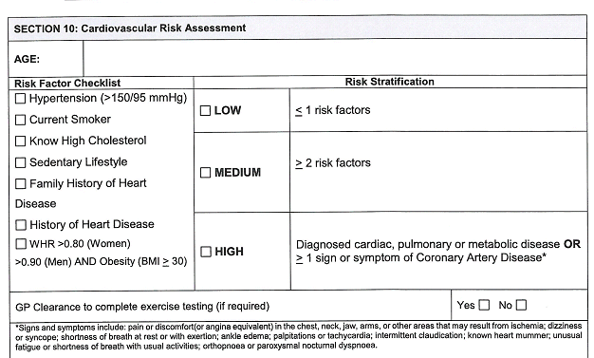
- Review medical history, medical assessment and question candidate to determine if candidate has any of Cardiovascular Risk Factors.
- Tick the relevant boxes for the risk factors they have.
- Tally the risk factors and tick the risk rating they fall into (Low, Medium or High)
- Ensure the candidate’s age in placed in the box indicated.
- Complete by a General Practitioner

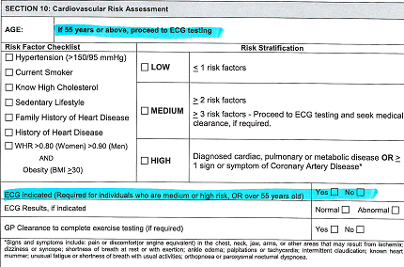
- If the patient is from Mineral Resources and aged over 55 or has 3 or more cardiovascular risk an ECG must be completed prior to completing the functional assessment and reviewed by a GP. Ensure three questions highlighted below are completed prior to commencing the functional assessment.

- Drug and Alcohol Screening (DAS)

Prior to completion of the tests, candidates are questioned as to any prescription or non-prescription medication or drugs that have been taken in the last fourteen days. Any declared medication should be noted on the chain of custody form.

Breathalyzer

- Instruct candidate to unwrap and attach the breathalyzer mouth piece.
- A long, soft blow (breath) is required into the end of the mouthpiece.
- The reading is classed as negative if its 0.000.
- A reading of any value is a ‘positive’ test and required to be retaken.
- Result sound be recorded to 2 decimal places on the Drug and Alcohol forms.
- Completed by Drug Collection Officer.

Lab Based Testing

- Instruct candidates to sign and date the seals for the sample containers.
- Patient details should be recorded and confirmed on DAS form.
- The candidate is then instructed to wash his/her hands and then take the small sample cup into the first or nearest toilet where they should fill the container with their own urine sample.
- The door should be kept open at all times and the toilet should not be flushed until checked by the tester.
- The sample is required to be extracted into three Monovettes and sealed, with the completed Chain of Custody form, in order to be sent to the Lab.
- Completed by Drug Collection Officer.

Instant Drug Screen

- Patient details should be recorded and confirmed on DAS form. Candidate is then instructed to wash his/her hands and then take the small sample cup into the first or nearest toilet where they should fill the container with a urine sample.
- The door should be kept open at all times and the toilet should not be flushed until checked by the tester.
- The sample should be poured in to an approved Instant Drug testing cup.
- The Instant Drug Screen form needs to be ticked as ‘negative’ or ‘non-negative’ dependent upon the result.
- Completed by Drug Collection Officer.

- Audiometry Test

- Prior to commencing the Audiometric test, candidates are required to be asked:
  - Have your been exposed to any loud noise in the past 16 hours? If so, how long and loud was the exposure?
  - Have you been on an airplane in the past 24 hours?
  - How did you get here today? Motorcycle or car?
  - Do you have any hearing problems, ear infection of cold that may affect the test today?

- Examine middle ear with the otoscope to identify wax build up or any other abnormalities.
- Inform candidate that they will hear a soft noise through the headphones, starting in the right ear first (or better ear) and then moving to the left. When they hear the tone they must press the button.
- Frequencies tested include 500Hz, 1000Hz, 1500Hz, 2000Hz, 3000Hz, 4000Hz, 6000Hz, and 8000Hz.
- ‘Normal’ hearing is classed as between -10 to 20dB for all frequencies.
- A degree of hearing loss is classed as a reading below 20dB for any of the given frequencies.
- Loss may vary between mild, moderate, severe and profound hearing loss.
- NOTE: Physiologist is to place and remove headphones in order to prevent damage to headphones and ensure they’re correctly placed over the ear canal.
- Complete Audiometry testing paperwork and once completed, results are explained to the patient.
- Completed by Audiometric officer only.

- Functional Capacity Assessment

Ask the worker to read and sign the functional assessment consent form on page 1 of the Functional Assessment, Upper Limb form. If this is not signed or the worker states there is a reason they cannot perform the work fitness assessment today, the assessment is ceased.

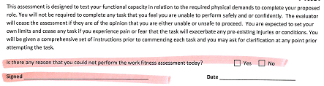

General Fitness Capacity Assessment

Range of Motion Assessment
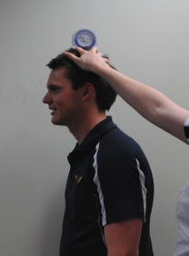 | Range of motion is visually assessed, unless the candidate reports a previous injury in the last 5 years (beyond a sprain or strain) or reports pain with a movement.  If the visual range is within normal range please tick the required box, if during visual assessment it is deemed restricted please measure and report number in box. For measured range please report the number in the box associated with that movement.  ** See below for range of motion instructions.  Note: If pain is reported proceed to extra testing for that body region.

Hamstring Flexibility
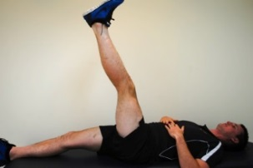 | The candidate lies supine with legs extended. The tester places the bubble inclinometer on the anterior tibia. The candidate then lifts their leg off the bed as far as they can, maintaining full knee extension on both legs. Perform twice, record best measurement and repeat for the other side. Record the best measurement for right and left next the L and R below the diagram. Circle the rating range that they fall into.  Note: Proceed to extra testing if candidate reports pain.  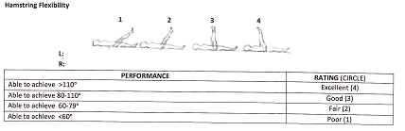
Upper Limb Strength Test: Grip Strength
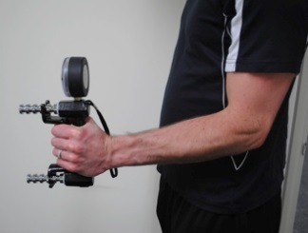 | The candidate is to sit/stand with elbow tucked in at side and flexed to 90°. Place the hand dynamometer in the candidate’s hand and instruct candidate to provide maximal grip force without rapid wrenching or jerking. Test each hand 2 times, record each and determine the mean. You record the normal range for right and left hands for their age group, their dominate hand, age and the range they fall into (Above, within, below normal range).  Note: Proceed to extra testing if candidate reports pain.  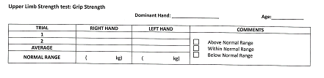

Full Depth Squat and 5m Duck Walk
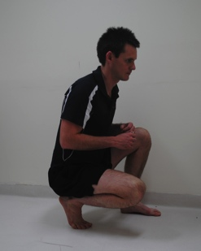 | Instruct the candidate to perform a deep squat as far as possible allowing their heels to come off the ground. Instruct candidate to walk forward 5 meters (15 steps). Rate their movement as unable, partial or able. If no pain reported during the movement tick the associated box. If pain is reported record pain out of 10 and region in the comment box.  Note: Proceed to extra testing if candidate reports pain.  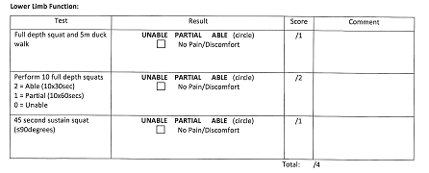
Squat Test
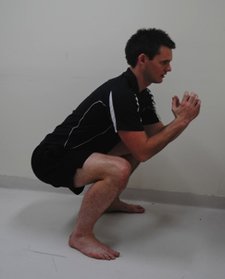 | Instruct candidate to perform 10 squats in 1 minute. Tester must ensure that each repetition the candidate reached 90° knee flexion with their feet flat on the ground otherwise repetition does not count towards the total. Record their performance using the guide below.  2/2 = 10 squats in 30 seconds = Able  1/2 = 10 squats in 60 seconds = Partial  0/2 = Unable to complete squat to 90° and maintain flat feet  If no pain reported during the movement tick the associated box. If pain is reported record pain out of 10 and region in the comment box.  Note: Proceed to extra testing if candidate reports pain.

Hold Deep Squat Position for 45 seconds
Instruct candidate to squat down to at least 90° knee flexion ensuring their feet remain flat on the floor for the entire test. Candidate must hold this position for 45 seconds. Rate their movement as unable, partial or able. If no pain reported during the movement tick the associated box. If pain is reported record pain out of 10 and region in the comment box.

Note: Proceed to extra testing if candidate reports pain.

3 Minute Step Test
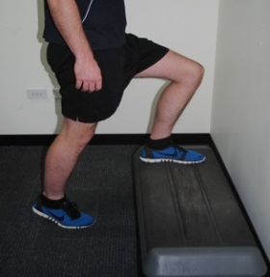 | The step height is set at 300 mm and the metronome set at 96 bpm. The candidate steps for 3 minutes, instructor must record heart rate at each 60 second interval in the table provided. After 1 minutes rest record the recovery heart rate in the table.  During the test, the tester observes candidate to look for signs of breathlessness, chest pain, dizziness etc. If they exceed 85% max HR, proceed only with doctor’s consent.  Use the recovery heart rate to determine the rating they fall into according to their age and gender.  Ensure the Age maximum heart rate (220-age) and 85% max heart rate is recorded below the box.  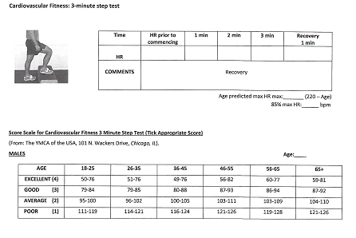

Core Strength: Prone Bridge
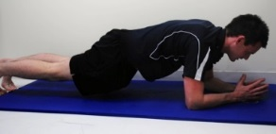 | Instruct the candidate to have their forearms and toes on the floor with elbows directly under their shoulders and assume the plank position. The tester is to ensure that the candidate keeps the spine in a neutral position. Candidate is to hold position for as long as possible to a maximum of 120 seconds, and the time is recorded. Circle the rating they fall into (i.e 95seconds = Good). Report effort used, pain experienced or if test is ceased due to poor technique.  Note: Proceed to extra testing if candidate reports pain beyond general muscle fatigue, during test.  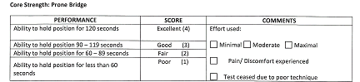

Floor to Waist Lift
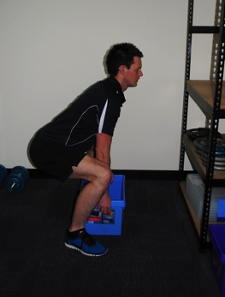 | Instruct candidate to lift box with 5kg off waist height shelf, place on the floor and then return back to the shelf. Assess technique and make corrections if necessary. If repetition is completed with correct technique ask candidate if they are comfortable increasing the weight and add 5kgs with each successful repetition until job specific requirement is reached.  Once the job specific weight is reached complete the remainder of the 10 repetitions at that weight.  If candidate is unable to reach the maximum weight with a safe technique instructor must cease test and complete remaining repetitions on the last safe weight.  In the table provided report the weight that each repetition was completed on. If candidate is able to achieve the weight requirement with good technique their rating is able, if they are unable to reach the maximum weight require their rating is partial or unable.  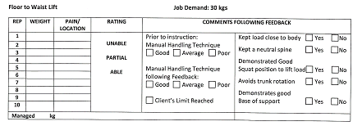

Waist to Shoulder Lift
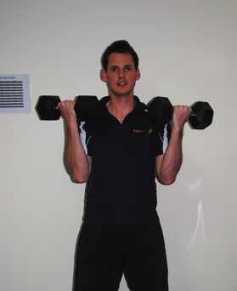 | Instruct candidate to lift 5kg dumbbell from waist to shoulder height and back again. Assess technique and make corrects if necessary. If repetition is completed with correct technique ask candidate if they are comfortable increasing the weight and move to heavy dumbbells. Once the job specific weight is reached complete the remainder of the 10 repetitions at that weight.  If candidate is unable to reach the maximum weight with a safe technique instructor must cease test and complete remaining repetitions on the last safe weight.  In the table provided report the weight that each repetition was completed on. If candidate is able to achieve the weight requirement with good technique their rating is able, if they are unable to reach the maximum weight require their rating is partial or unable.  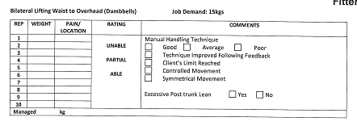

Shoulder to Overhead Lift
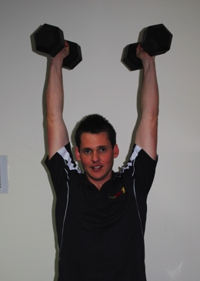 | Instruct candidate to lift 5kg dumbbell from shoulder height to overhead height and back. Assess technique and make corrects if necessary. If repetition is completed with correct technique ask candidate if they are comfortable increasing the weight and move to heavy dumbbells. Once the job specific weight is reached complete the remainder of the 10 repetitions at that weight.  If candidate is unable to reach the maximum weight with a safe technique instructor must cease test and complete remaining repetitions on the last safe weight.  In the table provided report the weight that each repetition was completed on. If candidate is able to achieve the weight requirement with good technique their rating is able, if they are unable to reach the maximum weight require their rating is partial or unable.  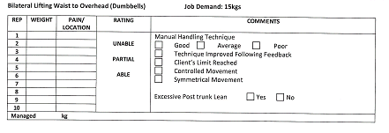

Bilateral Supine Chest Press
Instruct candidate to lie supine on a bench. Lift the 5kgs dumbbell from beside shoulders towards the ceiling and back. Assess technique and make corrects if necessary. If repetition is completed with correct technique ask candidate if they are comfortable increasing the weight and move to heavy dumbbells. Once the job specific weight is reached complete the remainder of the 10 repetitions at that weight.
If candidate is unable to reach the maximum weight with a safe technique instructor must cease test and complete remaining repetitions on the last safe weight.
In the table provided report the weight that each repetition was completed on. If candidate is able to achieve the weight requirement with good technique their rating is able, if they are unable to reach the maximum weight require their rating is partial or unable.

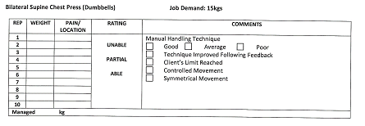

Waist Height Carry
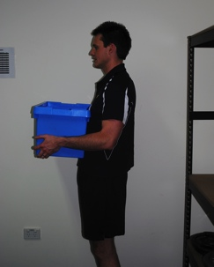 | Instruct candidate to pick up box from waist height shelf and carry 30m before returning back to shelf. Assess technique and make necessary corrections based on assessment criteria.  In the table provided report the weight achieve, pain levels, manual handling technique and trunk position. If they are able to achieve the job specific weight requirement their rating in able, if they are unable to reach the job specific weight requirement their rating is partial or unable.  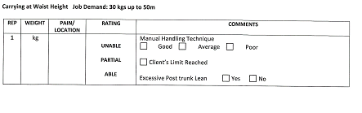

Dynamic Push/Pull of Wheelbarrow
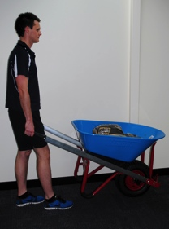 | Instruct candidate to grasp wheelbarrow with both hands, lift and push the wheelbarrow 20 m forwards. Then repeat by walking forwards and pulling the wheelbarrow behind.  In the table provided report the weight achieve, pain levels, manual handling technique and control of movement. If they are able to achieve the job specific weight requirement their rating in able, if they are unable to reach the job specific weight requirement their rating is partial or unable.  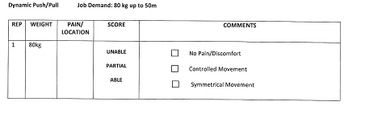

Functional Task Rating
Once all the job specific tasks are completed the Functional Task Rating must be completed.

To receive 4/4 for Technique the candidate must complete all repetitions (post feedback) with a safe manual handling technique. If the candidate is unable to maintain manual handling technque while completing the functional tasks a marks needs to be deducted depending on how far their technique strays from ideal technique.

To receive 4/4 for Performance the candidate must meet the weight requirements for each of the functional tasks in the assessment. If the candidate is unable to meet the weight requirements a mark must be deducted for each task they are unable to meet the weight requirement for.

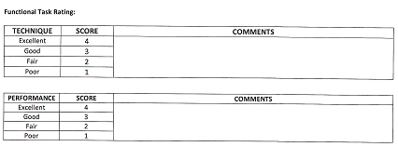

Functional Assessment Summary
The below table must be completed in full.

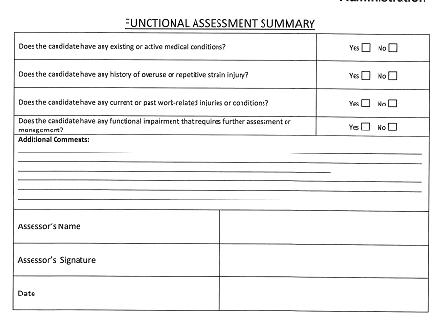

Range of Motion Guide
Range of Motion must be measured for a region if any of the below are met
- Candidate has had an injury in the last 5 years
- Workers Compensation injury in the last 10 years
- Injury in the last 10 years with associated below average general results (i.e lower back injury with poor core strength)
- Previous injury that could affect a specific job requirements (ie shoulder bursitis and a Silverchain, knee injury and a Scaffolder)
- If Pain noted with testing excluding general muscle pain

Cervical

Movement | Description
Flexion | Tester to stand side-on and place inclinometer on the top of candidates head. Instruct to stand straight, look down at the ground, bringing the chin to the chest. When visually assessed observe from side on. | 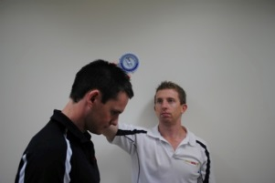
Extension | Tester to stand side-on and place inclinometer on the top of candidates head. Instruct to stand straight and look up towards the roof as far as comfortable. When visually assessed observe from side on. | 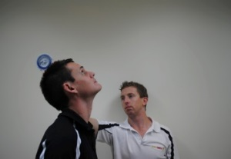
Lateral flexion | Tester to stand behind candidate with inclinometer on head. Place hand on right shoulder to prevent it from being raised and instruct the candidate to tilt their head to the left so the ear moves towards the shoulder. When visually assessed observe from in front or behind. | 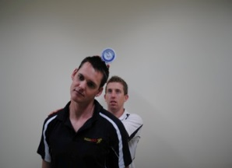
Rotation | Stand in front of the candidate and instruct to look over one shoulder, then back to the middle and to the other shoulder. Ensure the trunk is not rotated | 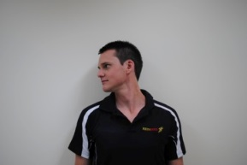

Back

Extension | Tester to stand side-on and instruct the candidate to stand tall and extend backwards from the hips. Ensure the hips and knees are not pushed forwards. When visually assessed observe from side on. | 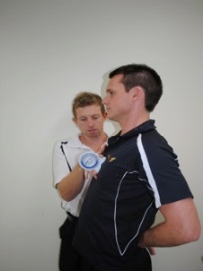
Lateral flexion | Tester to stand behind the candidate and place the inclinometer on the lateral aspect of the right upper arm. Instruct candidate to slide left hand down outside of thigh as far as comfortable. Ensure the right arm is kept by the side and the hips aren’t pushed out to the right. When visually assessed observe from front or behind. | 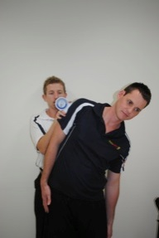
Forward Flexion | Tester to stand side on. Instruct the candidate to reach down to the ground keeping their legs straight and feet shoulder width apart. Record the distance from the ground. | 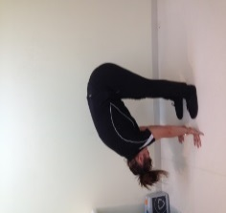
Rotation | Tester to stand front on, instruct the candidate to place arms crossed over chest and twist through the trunk region while keeping the hips neutral | 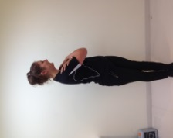

Shoulder/Elbow

Flexion | Tester to stand side on and instruct the candidate to stand straight with their arms by their side, keep the elbow straight and bring the arm forwards up past their ear. Repeat for opposite side. | 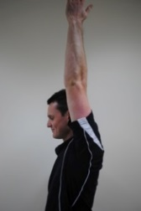
Abduction | Tester to stand front on, instruct the candidate to keep the elbow straight and abduct the arm as far as comfortable. Ensure shoulders stay level. | 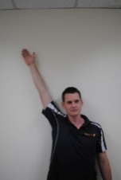
External Rotation | Tester to stand side on, instruct the candidate to place their right arm in 90 degrees shoulder abduction and 90 degrees elbow flexion. Place the goniometer on the candidates wrist and support the elbow while the patient fully externally rotates the shoulder. Repeat on the left side.
Internal Rotation | Tester to stand side on, instruct the candidate to place their right arm in 90 degrees shoulder abduction and 90 degrees elbow flexion. Place the goniometer on the candidates wrist and support the elbow while the patient fully internally rotates the shoulder. Repeat on the left side.
Flexion | Tester to stand side on and use the goniometer when measuring – place the center of the goniometer over the lateral epicondyle and instruct the candidate to keep elbows by their side and bring hand up to shoulder (flex at the elbow). Can be visually assessed from side on. | 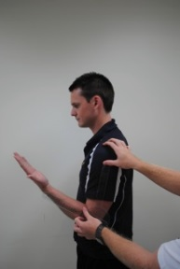

Wrist

Pronation | Instruct candidate to sit with elbow on a desk, elbow tucked in by the side and bent at 90 degrees. The wrist should hang over the edge of the desk. Place the inclinometer on the dorsal aspect of the hand and instruct the candidate to turn the palm down towards the floor. | 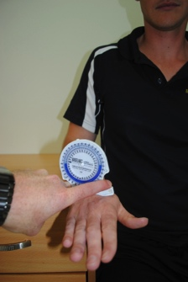
Supination | Instruct candidate to sit with elbow on a desk, elbow tucked in by the side and bent at 90 degrees. The wrist should hang over the edge of the desk. Place the inclinometer on the palm of the hand and instruct the candidate to turn the palm up towards the roof. | 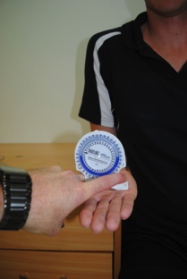
Flexion | Instruct the candidate to rest elbow on the desk with forearm vertical and palm neutral and thumb towards shoulder. Place the inclinometer on the dorsal aspect of the hand and instruct the candidate to bring the palm down towards the floor. | 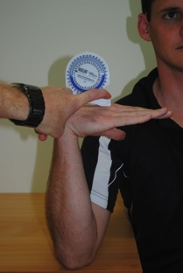
Extension | Instruct the candidate to rest palm face down on desk, elbow flat on the desk and close to body. Instruct the candidate to raise palm off the desk without lifting elbow. | 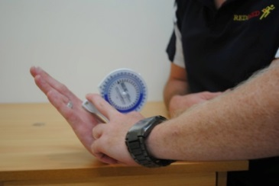
Ulnar deviation | Candidate to start in same position as for extension. Tester places small goniometer with the center of the goniometer over the carpals and the midline running through the 3rd metacarpal and the middle of the arm. Instruct the candidate move hand away from the body, without shifting the arm or wrist. | 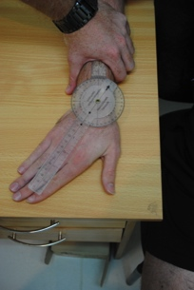

Radial deviation | As for ulnar deviation, instruct the candidate to move the hand towards the body. | 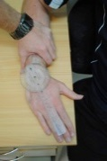

Hip/Knee/Ankle

Flexion | Instruct the candidate to lay on their back with legs straight. Place the inclinometer on the anterior thigh and instruct the candidate to bring their knee to their chest (without assistance from the hands) | 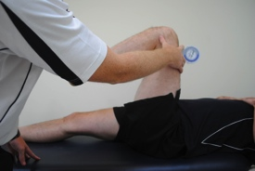
External rotation | Instruct the candidate to sit on the edge of a plinth, feet hanging over the edge, with knees and feet together. The examiner places a hand on the outside of the left knee to prevent it from moving laterally. The candidate brings the right leg back and takes the left foot across the body. The inclinometer is placed on the lateral aspect of the lower leg | 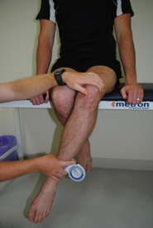
Internal rotation | As for external rotation, however the foot is taken away from the midline. Ensure the hip is not lifted.
Flexion/  Extension | The candidate lays face down with feet hanging over the edge of the plinth to ensure the leg is at 0°. The inclinometer is placed on the posterior lower leg and the candidate curls the leg towards the backside. | 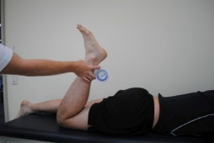
Rotation | Sitting on the plinth, the candidate rotates their ankles in both directions. | 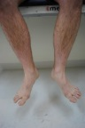
Plantar/  dorsiflexion | Sitting on the plinth with legs dangling, the foot is plantar/dorsiflexes. | 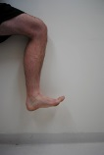  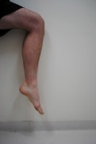

- Extra Testing Protocol

Required to be completed if;

- Candidate has had an injury in the last 5 years
- Workers Compensation injury in the last 10 years
- Injury in the last 10 years with associated below average general results (i.e lower back injury with poor core strength)
- Previous injury that could affect a specific job requirements (ie shoulder bursitis and a Silverchain, knee injury and a Scaffolder)
- If Pain noted with testing excluding general muscle pain

Back Assessment

Extensor endurance test
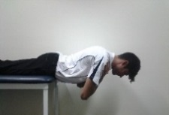 | Instruct candidate to lie prone on the plinth with the top of their hips in line with the edge of the bench, legs flat and hands on the floor or step. Tester is to secure candidates legs to the bench with the strap. Instruct candidate to bring arms across their chest and hold their torso horizontal to the floor for a maximum on 90 seconds. Test is ceased in candidate reports pain or candidate falls below the horizontal position.  Able = ≥90seconds  Partial = 30-90 seconds  Unable = ≤30seconds
Thoracic Extensions
Instruct candidate to lie prone on a mat with their fingers on their temples. Instruct the candidate to lift their chest off the bench and then return to the start position. Movement is to be complete 5 times. Test ceased is candidate reports pain.
Able = ≥ 5 Repetitions
Partial = 1-4 repetitions
Unable = unable or with pain
Prone Hip Extensions
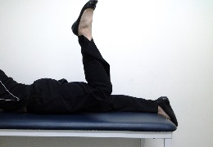 | Instruct client to lie prone on a mat. Instruct client to bend the right leg and extend at the hip to bring their knee off the ground. Client must complete 5 repetitions on each leg. Repeat on the other side. Ensure client keeps their pelvis stable, that their ASIS could maintain contact with the ground at all times and that the movement is being initiated by the gluteals not the hamstrings.  Able = ≥ 5 Repetitions  Partial = 1-4 repetitions  Unable = unable or with pain

Shoulder Assessment

Resisted Shoulder Internal/External Rotation
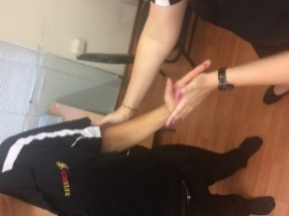 | The tester, in opposition to the movement of the candidate, applies sufficient resistance to ascertain any symptoms that would be of concern.  The specific movements targeted in this assessment are shoulder internal rotation and external rotation with the elbow at side and flexed to 90°. Tester to support the candidates elbow.
Resisted Shoulder Abduction/Adduction
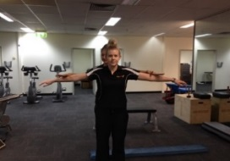 | The tester, in opposition to the movement of the candidate, applies sufficient resistance to ascertain any symptoms that would be of concern.  The specific movements targeted in this assessment are shoulder adduction and abduction with the shoulders in 90° shoulder abduction.
Sustained above shoulder
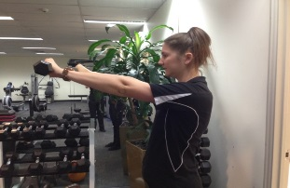 | Instruct candidate to hold a 1kgs dumbbell in each hand and hold the weight at 90° degree shoulder flexion for 1 minute. Test is ceased if candidate reports pain in the shoulder or either/both arms fall below the 90° shoulder flexion position.
Push up test
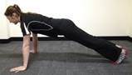 | Instruct the candidate to lay prone on the ground/mat. Arms are placed shoulder width apart. Instruct the candidate to maintain a neutral spine and use their arms to push up. Slowly lower down. Candidate is to complete a total of 10 repetitions, 3 on the wall, 3 on their knees and the final 4 on their toes. If candidate is unable to complete any stage, complete the remaining repetitions on the stage below. Ie. Unable to complete toes repetitions complete remaining on knees.

Elbow/Wrist Assessment

Resisted Upper Limb Testing
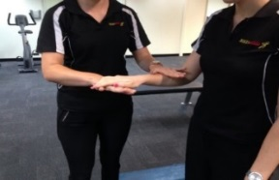 | The tester, in opposition to the movement of the candidate, applies sufficient resistance to ascertain any symptoms that would be of concern.  The specific movements targeted in this assessment are wrist flexion and wrist extension with the elbow in 90° and wrist horizontal to the ground.
Repetitive Forearm Pronation/Supination
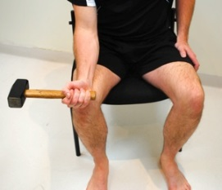 | The candidate is instructed to place forearm on leg with elbow bent at 90° and grasping a mallet. While grasping the mallet, the candidate is to fully pronate, then fully supinate within the pain free range. Perform 10 repetitions of this. The tester is to observe and note any abnormalities.
Repetitive Wrist Flexion/Extension
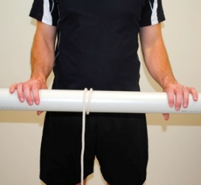 | Instruct the candidate to hold the pipe out in front in both hands and use their wrists to roll the rope up the pipe, causing the 1.25 kg weight to move up. Change directions to move the weight down and repeat 3 times. The tester is to observe and note any abnormalities.

Hip/Knee Assessment

30 second sustained kneel
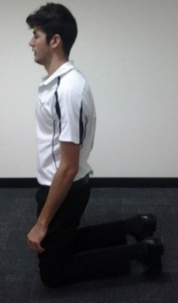 | Instruct candidate to assume a kneeling position. Candidate must hold position for a maximum of 30 seconds. Instruct candidate to stand without using the assistance of their arms or a bench.  Able = ≥30seconds and standing without arms  Partial = ≤30seconds or require padding or unable to stand without using arms.  Unable = unable to assume position
Lunge Test
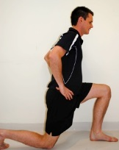 | The candidate is instructed to perform 10 full depth (5 on the right and 5 on the left), walking lunges. Tester to stand side on and observe the range through the hip and knee, depth or squat and symmetry on movements.
Hop test
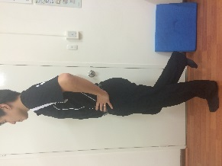 | Instruct candidate to complete 5 hops moving in a straight line across the room. Tester to look at symmetry of movement and report any pain associated.
4 point kneel
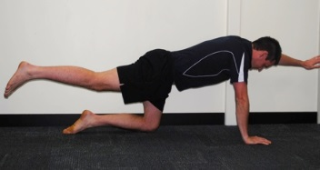 | The candidate is instructed to assume the 4-point kneel position with neutral spine. Then extend one arm and the opposite leg out straight, ensuring the spine and pelvis maintain their neutral position and the hips and shoulder don’t tilt to one side. Lower, alternate sides and perform of each side 5 times. Tester to observe hip position and control during movement’s record any abnormalities.

Ankle Assessment

Resisted Plantarflexion/Dorsiflexion
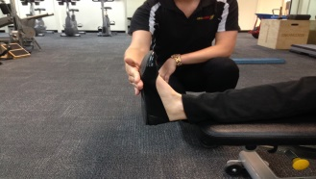 | The tester, in opposition to the movement of the candidate, applies sufficient resistance to ascertain any symptoms that would be of concern.  The specific movements targeted in this assessment are ankle dorsiflexion and Plantarflexion with the ankle in a neutral position.
Dura Disc Balance Assessment
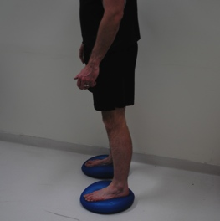 | Instruct candidate to stand on the dura discs, one foot on each dura disc. Ensure the candidate has good balance and back is kept straight. Hold the position for 30 seconds or as long as possible.  Able = ≥30 seconds  Partial = ≤30seconds  Unable = Able to perform test
Heel-Toe Walk on Foam Beam
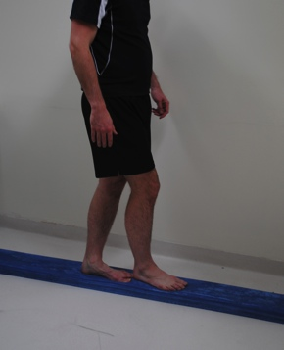 | Instruct the candidate to walk along the foam beam by placing the heel of one foot directly in front of the big toe of the other. Once at the end of the beam, walk backwards by placing the big toe of one foot directly behind the heel of the other until back at the start. Observe candidate and record findings.  Able = Forwards and Backwards  Partial = Forwards only  Unable = Unable in either direction

- Spirometry Test

- The candidate’s information is required to be put into the spirometry machine correctly (DOB, height, ethnicity, gender and smoking status).
- Instruct the candidate to select a tube and place it in the blower. Tester must not touch candidates white tube.
- Instruct the candidate to take a maximum breath in, lightly bite down on the tube, seal their lips around the tube and forcefully blast out their breath and hold on her as long as possible.
- Instruct candidate to not breathe in through the tube.
- After each attempt tester must examine the graph to ensure it has a strong peak at the beginning and discard the attempts that do not meet the requirements.
- Tester must ensure they have three results that are within 0.15 of each other before candidate can cease test.
- The tester must ensure both FVC and FEV1 have three results within 0.15L of each other before the candidate can cease testing.
- A result equal to or above 80% for the FVC, FEV1 and FVC/FEV1 ratio can be considered normal.
- Physiologist is to review and explain the results to the patient.
- Completed by Exercise Physiologist or Nurse.

Once the REDiMED Pre-employment medical is completed please ensure all the paperwork is fully completed and in the following order:

- Booking form
- Identification
- Medical History
- Medical Assessment(s)
- Drug and Alcohol Screening Form
- Audiometric Testing Sheets
- Functional Capacity Assessment
- Extra testing (if required)
- Spirometry print out

Completed files need to be scanned in and emailed to REDiMED within 24 hours of the candidate’s appointments.

Failure to meet the required KPI’s, i.e. failure to return or complete the required paperwork per the testing standards and timeframe outlined above, may result in the actions outlined in the Service Agreement.

